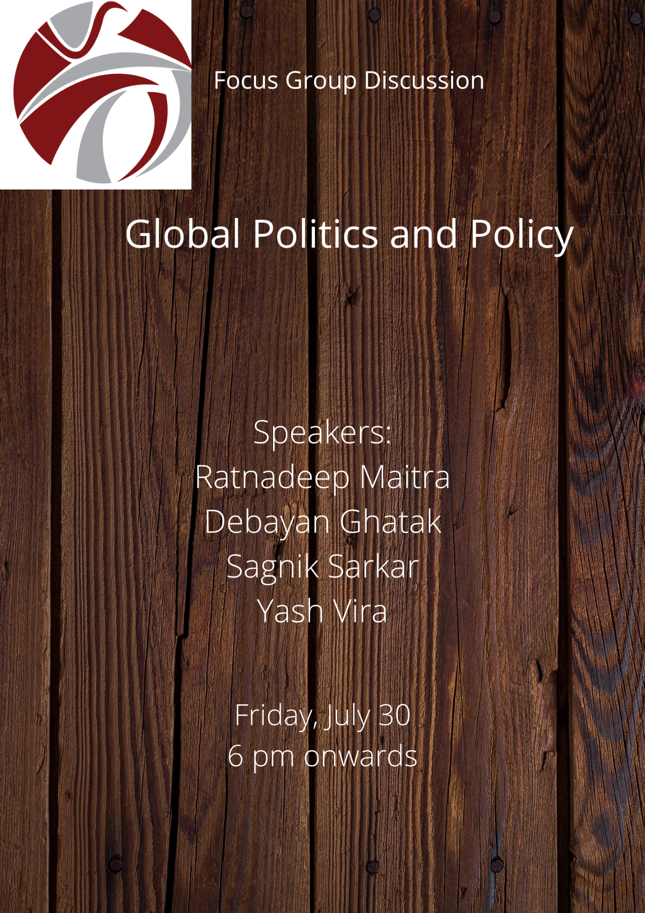
Asia in Global Affairs hosted a Focus Group Discussion, “Global Politics and Policy” on 30th July, 2021. The panel had four AGA interns as participants- Ratnadeep Maitra, Debayan Ghatak, Sagnik Sarkar, Yash Vira. Professor Swaran Singh, Professor and Chairperson CIPOD, JNU was invited to the webinar as an external expert. The following is a brief account of the principle arguments as presented by the respective discussants in the order of their speaking.

Ratnadeep Maitra spoke on 100 years and beyond: The Rise and Rise of the CCP. Ratnadeep began by noting that the Chinese Communist Party (CCP) celebrated its 100th anniversary on 1st July 2021. The CCP has always been regarded as the sole agency for reviving the long lost stature of China. The slogan “China is not the country it was a hundred years ago” has been adopted to portray China's unflinching posture. One of the favorite ways of the political elites to defend their policy-decisions is by the romanticising and embelleshing historical memories. The party propagates a history that is filtered and cleansed of negative events and also one that glorifies the way the party brought peace and prosperity to the nation. Ratnadeep also focused on how the CCP’s attachment to Marxist-Leninist principles, though toned down to a significant extent, is still evident and President Xi has expressed his wish to open up “new frontiers for Marxist political economy”. The CCP has exhibited dexterity in harnessing the Chinese economy leading to a gradual advancement of life of the Chinese citizens, thus adhering to the truest Marxist principle. The CCP has also penetrated every corner of the nation with over 19 million active members. By politically catering to the diverse social groups across the country, the CCP has curbed the scope of political antagonism. Ratnadeep, simultaneously, threw light on the burgeoning issues in the political body of China, most noticeable of which is the widespread corruption within party ranks. On the other hand, he argues that the modernization drive has led to the rise of an educated and affluent middle class in China who have been exposed to the western media and are thus beginning to realize the isolation that CCP has kept them in, consequently sparking a public outcry. The CCP, Ratnadeep argues, must achieve an equilibrium in which, besides its own publicity campaign, the internet must also be democratized. Ratnadeep concludes by saying that one of the biggest weaknesses of CCP, even after a century of functioning, perhaps lies in its tendency to forget the past as evident from its attempts to erase from the public memory events like the Tiananmen Square massacre, the Great Leap Forward and Cultural Revolution. The longest running communist party in the world still cannot trust its own citizens, give them a space to freely voice their opinion, and empower them to choose their own leaders.

Debayan Ghatak spoke on “The Securitization trend in World Politics amidst the Covid 19 Pandemic”. Debayan started his presentation by focusing on the deep standing malice embedded in world politics that the Covid-19 pandemic has shed light on. The G-7 nations along with the important countries in the Global South, have been using terms like ‘national security’ and ‘existential threat’, to define their respective Covid-19 response, leading to a high degree of ‘securitisation’ as proposed by Barry Buzan. Such aggressive rhetoric directed against the ‘invisible enemy’, has led to depletion of democratic rights globally. The renewed focus upon the ‘duties of the state’ is likely to make leaders of some of the leading nations face public wrath in the imminent elections, based on their contingent pandemic response. Some politicians, by focusing on war, enemy and battle, called for the pooling in of all the state’s resources while shaping their respective pandemic response. Such generalized proclamations of emergency, if resorted to in a post-pandemic scenario, has the potential to induce democratic erosion. A ray of optimism amid all this gloomy political aura is South Korea and New Zealand whose non-protectionist response to meet the challenges of the Covid-19 pandemic, aptly represented an ‘effective democratic ethos in operation’ during the crisis. Their pandemic response, as Debayan says, is an important model for a post-Covid-19 multilateral world order. These two novel examples sharply contrast the overall impending ‘war narrative’, that some major powers portend in the post-Covid international security framework. Debayan opines that if the conceptual framework of ‘securitisation’ is brought into operation in a Covid-19 induced world order, then the question of ‘national security’ might re-design the social contract, between the citizen and its representative government.

Sagnik Sarkar spoke on “The Relevance of NATO in the Contemporary World”. Sagnik commenced his presentation by focusing on the revival of NATO. NATO, with currently 30 members and headed by the US, was formed during the cold war with the common goal of ‘collective security”. However, the intensity of this goal got somewhat weakened over the years. It further deteriorated during the administration of the former US President Donald Trump who expressed his ‘disgust’ towards NATO by branding it ‘obsolete’ and a relic of the cold war. He threatened to pull the US out of the alliance and even falsely accused many European members of NATO of ‘using’ America through this alliance. Apparently, Trump’s failure to win the 2nd term in office in the 2020 US election proved to be a blessing for the European members. Now, the new US president, Joe Biden, is trying to undo the damage done to NATO and revitalize it. Biden considers NATO important for shaping the US foreign policy, for restoring traditional alliances and strengthening ties with the international community. Even at the G7 Summit in Cornwall, Biden announced that the US was ‘back at the table’ and had restored its presence. Unlike Trump, Biden views NATO as a must to ensure America's sole superpower status. However, NATO still faces numerous challenges. In the recent NATO Summit in Brussels, besides emphasising on the need to consolidate the alliance's unity, Russia and China's aggressive behaviour were labeled as strategic challenges. With NATO's revival, China is believed to be the ‘new Soviet Union’ and the US is determined to contain China's rise. Also, attempts to include Ukraine and Georgia into the US-backed alliance are sure to agitate Russia which might have grave ramifications for world security. Moreover, there is also Turkish threat looming over NATO which is evident from Turkey’s (also a NATO member) mistrust towards the US. Turkey intruding into Syria with Russian air defence system has further irked the US. Besides, the European members are still skeptical about the US’s role - “thanks” to Trump's tumultuous regime. Sagnik went on to note that NATO, despite its internal problems, has always recovered and most importantly, the US is significantly going to rely on NATO and transatlantic ties in order to maintain its unipolar status.

Yash Vira spoke on “Global Supply Chains, the Global South and a Global Pandemic”. Yash, through his presentation, tried to argue why it was necessary to have a diverse supply chain to fight the unpredictable global health shocks. The Covid-19 pandemic induced the shutting down of the global economy which exposed vulnerabilities in the production process and supply chains in virtually every country. This also saw the rise of economic nationalism, temporary trade restrictions, shortages of medical supply accompanied with global recession. The pandemic also exposed the global interdependence of supply chains in medical products needed to tackle covid-19. Also, making a vaccine requires materials produced from several different countries which are dependent on smooth supply chains. Yash focuses on the supply chain situation in India. India's import of Covid-19 related products increased significantly during the pandemic while that of the non Covid-19 related products reported a decline. At the same time, India increased its export of Covid-19 products like PPE kits, alcohol solutions and swabs, test kits, ventilators etc Moreover, India has one of the highest import tariffs in the world on Covid-19 related products which it needs to abolish in order to strengthen India's participation in the global supply chain of anti-Covid-19 products including vaccines. It was only when the second wave of Covid-19 virus took a deadly form in India in the month of April, that the government waived off the basic customs duty on the imports of oxygen and oxygen related instruments to meet the sudden drastic rise in the demand for the same. Furthermore, the nationwide lockdown gravely affected transportation and logistics. The Covid-19 virus massively challenged the Indian economy. The policy makers are continuously looking inward to fight the pandemic and this has aggravated the supply chain mechanisms. Yash stressed on the question whether India should retreat behind a wall of trade barriers and pursue inward looking policies to meet the challenge. More importantly, he highlighted the need for global coordination in smoothing the global supply chain to be able to more effectively tackle any kind of future disruptions.
The discussion concluded with Professor Swaran Singh providing invaluable observations on each of the speaker’s presentations.
Report prepared by Ankita Chatterjee
Intern, Asia in Global Affairs

