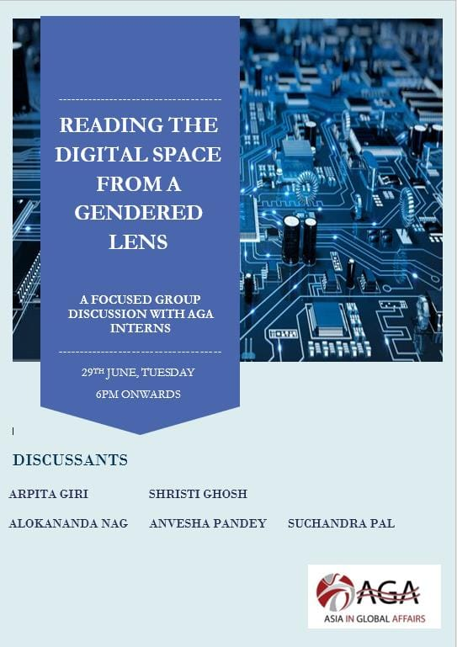

Asia in Global Affairs hosted a Focus Group Discussion that revolved around the theme of Reading the Digital Space from a Gendered Lens' on 29 June 2021. The session was moderated by Somdatta Chakraborty, Senior Adjunct Researcher of Asia in Global Affairs. The panel had five active participants, namely - Arpita Giri (Adjunct Researcher, AGA) Srishti Ghosh, (Intern, AGA) Alokananda Nag, (Intern, AGA) Suchandra Pal, (Intern, AGA) and Anvesha Pandey, (Intern AGA). The participants reflected upon four fundamental questions-
- Do you feel digital media especially social media acts as a class and gender leveller in any way? Please discuss.
- What is your view on the inter-generational use of the digital especially social media? Do you see any difference in the way your elder generation takes to social media as compared to you? Discuss.
- What is the relevance of e-commerce and local Kirana or grocery shops in your ecosystem? Do they co-exist? Discuss.
- Do you believe that digital media empowers women? If yes, please discuss instances of trolling, body shaming, distribution of fake news etc. on social media and how do women manage to empower themselves by negotiating those?
Alokananda Nag commenced the session by addressing the fourth question.
She began by giving an overview of 'digitalization' and how everything around us that can be digitalized has been digitalized. According to her, civil society and humans are gradually contributing and adapting to the age of digitalization. Then she moved on to talking about the role of women, preferably female mentoring, in the digital world by giving the example of Augusta Ada, the first female computer programmer. She associated her example with the tragic fact that the digital space is dominated by male tech pioneers. And the female role models are mostly neglected and not given much recognition. She further suggests, by using the example of Isis Anchalee, that female mentoring over the digital space can enhance and influence the participation and expression of women in careers concerning technology. According to her, social media is not too so social. She focused her arguments on 'unsocial' media and the dark side of the web as a result of several menaces such as hate crimes, revenge porn, cyberbullying, and more. She stated that threats such as rape and abduction have led to a condition called the 'silencing strategy' thereby preventing women from participating in any public or social media forum. She then recommended methods such as relaunching examples of successful women that will empower others online and encourage them to speak their minds. Alokananda raised an important question, that is, "Why target a woman?" In her opinion it is probably due to the fact that society acts out aggressively to tame women that they feel are acting outside their social norms and boundaries. She finally concluded by talking about the importance of female mentoring. Using the example of Priyanka Kumari, she opined that it is essential for women to step up and embrace their journeys so that other women can do the same. She also advocated for digital education and increased participation for women in the corporate realm.
The second speaker, Arpita Giri provided her observations on the first question. Her first observation suggested that the accessibility of the internet is highly unequal in the rural and urban areas which is further accelerated along the lines of gender. She opined that the frequent use of digital media is confined mostly to the urban regions than the rural areas. Her second observation reveals the backwardness of the educated, affluent families in the urban areas. These families restrict the usage of social media and technology by female members. Their social media posts and usage of technology is regulated by the spouses that compel them to create fake Facebook accounts. Giri also contends that the structure of the neo-liberal economy is exploiting and objectifying women. Her final observation describes the discrimination on the usage of smartphones in rural areas. The male members use smartphones more compared to the female members. She says that women are either hindered or minutely observed and regulated by the male members while using their gadgets.
Srishti Ghosh, began by elaborating on the theme that if digital media truly plays a transformational role. According to her digital media has a huge role in promoting gender equality and acts as a level player. Srishti observed that this level playing role of digital media, however, largely depends on the place's political and socio-economic setting. She added that patriarchy and religion have a huge impact and act as a constraint in the presence of women in the digital space. She further added to her speech about the existing stereotypes against women. According to her low literacy rates, fear of social acceptance, pre-formed opinion of their incompetency by the society, parental pressure denies them their access to the digital space and which in a way limits the potential of the digital world in itself. However, she says that over the years many women entrepreneurs, content creators, activists, etc., have emerged who have portrayed their skills over a wide range. This has proved that once women come out of their social stereotypes and make their presence digitally, gender-based subjectivity doesn’t have that limiting strength anymore. Srishti goes on to explain that in fact, social media has created a space for solidarity. She associated this statement with the example of the "me too" movement which created large-scale awareness among people regarding the humiliation that women face. As a result, women have become more confident and there is increased participation of them in the digital sphere. Coming to the second theme of intergenerational use of social media, Srishti spoke about the huge gap in the pattern of usage among the older and the younger generation. In her opinion the older generation is very reserved and less likely to engage actively on social media. However, this overgeneralization of them not using social media isn’t good as social media has proved to be a great platform for showcasing talents even for people of their age. Srishti further explains how on the other hand the younger generation’s obsession with social media has led to several issues including even mental illness. On the third theme, Srishti spoke about the co-existence of local markets and e-commerce in the era of digitalization. She goes on to explain that even though many e-commerce websites have emerged for buying groceries, there still is a preference for buying them physically from the shops themselves. E-commerce is mainly preferred by the younger generation and people who often travel for work. Srishti then went on to answer the next question which is- if at all digital media empowers women? she agrees to it and says that in almost every country including India digital media has in a way, empowered women. According to her, the entire idea of women being subjected to various restrictions can be connected to the social barriers that exist.

Speaker 4: The fourth speaker, Anvesha Pandey, voiced her opinions on the fourth question. She beagn her discussion by stating that how Digitalization has changed its way. She gave her opinion on the fact that social media is a platform that helps people to learn. And the journey of the role models influences others to do better. Moreover, social media has helped individuals to learn new skills and also showcase the talents they have before others. According to her social media has become a platform to search for new career opportunities. Women can get a variety of career options and thereby can become their own boss. She even gave examples of Richa Singh and Richa Kar who with the help of Social-Media have empowered themselves. Taking their inspiration several other women have also come forward to take new career options and be independent and successful in life. Anwesha came up with two different sides of social media. According to her social media has its impact both positively as well as negatively. She pointed out that how social media apart from being a platform for opportunities is also a platform via which people spread hatred in form of demotivating messages, online threats, trolls and even body shaming. The speaker gave a very strong statement here that not only the real world but the virtual is also equally unsafe. Beauty brands increase insecurities among women and reduce their confidence in coming up with new content. She in her speech stated that illiteracy and barrier in the language is acentuating the differences between male and female. With all her valid points Anvesha reiterated the need for proper use of technology and proper use of social media. Technology should be made available to all so that everyone can use it for their self-development as well the development of our country.

Speaker 5: The final speaker of the FDG, Suchandra Pal, reflected upon all four questions. She began by stating that social media has become a crucial part of our daily lives, especially during the pandemic. Suchandra goes on to draw the comparison between older and newer generations and how the accessibility and usage of the internet and gadgets have increased over the due course of time. With the advancement of information and communication technology, social media is perceived not only as a networking tool but also as a platform for wider exposure and representation. But this expansion is restricted only to the privileged class. The marginal community cannot enjoy this liberty of self-expression because of ill-literacy, bully, financial constraints, language barriers, family restrictions, cyberbullying, and more. Considering all these factors, she opined that social media does not guarantee security despite empowering people. She moved on to the question of the gender gap where she stated that the pandemic has made the usage of technology fundamental to all age groups, thereby levelling the age gap between different generations. Moreover, she highlighted how social media such as Instagram and Facebook have provided women with opportunities to run small businesses, digit content, marketing, and more such initiatives that have helped employment and independence during the pandemic. However, social media is equally responsible for inciting violence and trauma. Thus, it ultimately fails in holistically empowering people, especially women.
Q&A:
Dr Somdatta Chakraborty initiated the discussion by proposing two questions- first, "what is your view on the multitasking ability of women through digital media and how does it help in sustaining different aspects of their identity?" and second, "What are the different reasons behind women opening multiple accounts on social media?
The first question was answered by Alokananda Nag. She opined that social media has helped women to carry out their regular work and at the same time nurture their hobbies and take care of their families. She supported her arguments with personal observations. Akanksha Tiwari responded to the second question. She opined that it is not only the restrictions imposed by the family but also the act of living out the ugliness by taking refuge behind the fake accounts. Dr Chakraborty and Alokananda Nag further added that creating fake accounts have positive effects too. It has helped people create meaningful relationships online and heal themselves from personal problems in the process of doing so. Debayan Ghatak, (Intern, AGA) made a crucial observation thar revolved around a much better sex ratio in the tribal belts regarding the vaccine uptake compared to the urban regions. He then asked about the possibility of such development and can the success of Digital India Campaign throw up new prospects towards women centred digitalization in these locales? Priya Singh, Associate Director of Asia in Global Affairs, responded to the queries. She opined that whenever the tribal belts are taken into considerations factors such as the provision of the fifth schedule, geography, development, conversion, availability of resources, and more must be taken into account as it Is not a homogenous category. The session concluded with Dr Chakraborty sharing her observations gathered through different FGDs on interrelated themes conducted over a period of time.
Report prepared by Aakansha Tiwari.

