Report
Connectivity across Asia

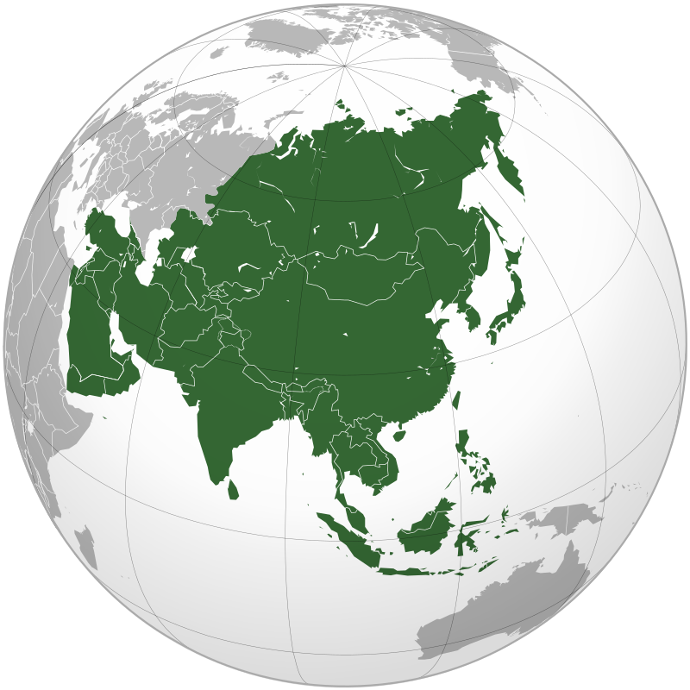
Asia in Global Affairs hosted a webinar entitled ‘Connectivity across Asia’ on 3rd April, 2021 where the distinguished speakers were Professor Shibasish Chatterjee, department of International Relations and Governance, Shiv Nadar University, Professor Shantanu Chakraborty, department of History, Calcutta University and Professor Anindyo Jyoti Majumdar, department of International Relations, Jadavpur University respectively. The following is a brief account of the major arguments as presented by the respective discussants in the order of their speaking.
Professor Shibasish Chatterjee was of the opinion that in order to understand the concept of connectivity as an essential subset of geopolitics in general it is pivotal to understand three things in particular namely how is the notion of connectivity been encountering the overarching influence of globalization in general, how is this conspicuous theme providing an essential idea of spatiality amidst the global commons and lastly the political dimensions entailing the concept of connectivity should be highlighted too.
Concerning our first area of inquiry we may safely say that under the aegis of globalization the idea of state sovereignty is being challenged from both ‘within’ and ‘without’. Along with the aforementioned area of contestation some allied domains like the idea of citizenship, humanitarian aid and migration are also facing much churning. But the concept of sovereignty itself can be very much paradoxical as in the ancient and medieval times too we cannot see any instances of a state having an absolute control over its territory, people and fundamental resources as completely separate from the rest of the world thus putting the all-encompassing globalizing arguement on its head.
Concerning our second area of inquiry we can look at the concept of liberalism and its concomitant evolution, serving as a major fulcrum of the globalizing drive. Liberalism as an ideal owes its very existence to the idea of modernity itself which its respective suitors can mend according to their emergent needs. Despite facing some minor disruptions as in the Second World War the liberalizing ideal has witnessed an onward trajectory finally culminating in the age of ‘hyper connectivity’ in the context of the Covid-19 pandemic. It is here that this globalizing ideal becomes very much problematic as while technology and connectivity flows present one side of the coin the conscious effort to map out borders and employ tools of statist surveillance present another. Here the increasingly technocratic assumptions and standardization of infrastructural norms constitutes an active effort to efface the political ‘other’ as concerning the ideal of connectivity itself.
Concerning the final area of our inquiry it is essential to decipher the ‘geo’ from the ‘politics’ itself whilst harping upon the varying notions of connectivity in general. While the liberal perspective harps upon the normative ideal of connectivity leading to a model of deliberative politics it also pits it as an independent variable as contributing to certain far reaching consequences. The multidimensional foreign policy of China as is being manifested through the BRI initiative is the essential alternative while focusing upon the buildup of economic inventories, digital ecosystems and nodal transportation hubs as devoid of any normative commitments while harping upon the practicality and necessity of participating in such an endeavor. The emerging construct of connectivity which wants to challenge the BRI's pioneering narrative is unambiguously on the back foot with its focus being the establishment of the rule of law, ensuring transparency and effectuating a sense of general humanness towards the entire enterprise. The degree to which such an essential theorization may offer a credible alternative to the BRI itself would depend upon the political will of its patrons in the ultimate extent.
Professor Shantanu Chakraborty put forth the view that the concept of connectivity despite being predominantly conceived to be an essential byproduct of the idea of globalization itself has its roots in several other epochs and their concomitant time frames. It is essential to take note of this rich historical trajectory because it has the potential of communicating to us certain ‘lived experiences’ which may help to further our understanding regarding this particular theme.
In ancient times as people used to travel and encounter civilizations that were mostly unknown to them they took the help of various scientific tools as well such as the astrolabe and others. The concept of having certain merchant premiums to secure one's future while moving into an uncertain and distant commercial endeavor formed an integral part of this thought process. Later on during the 18th and 19th centuries people took part in various geographical expeditions for the purposes of adventure seeking or merrymaking also. Thus while it is essential to understand the concept of connectivity from above it is also essential to look at this theme from below from the perspective of forging a strong people to people connect. Various indigenous accounts of connectivity remain mostly in the archives having a tremendous potential of harboring some untapped exploratory fields. Take for example Bimol Mukherjee whose travels through the heart of Europe brings into focus the differing notions of imperialism, the central contest as waged between nationalism and colonialism and his urge to understand the perspective of several non-Indic civilizational ethos. Bhai Sunder Singh on the other hand was a Christian missionary having an essential Punjabi origin who wanted to propagate the role of Christianity and colonialism as being progressive constructs. Some Chinese scholars based in the US have also tried to focus upon the aspect of an 'invisible Chinese enemy' which accompanied Chinese migrants the world over and is curiously a part of the current strategic psyche as well.
While the state's central role in augmenting connectivity projects can't be ignored the Covid-19 pandemic has aggravated the operability of emergent technological mediums to sponsor digital connectivity as can be manifested through the holding of international webinars via an online video conferencing platform. The technological inputs of the 1980s helped to bring about such a connectivity transformation of epic proportions. While we may try to draw a distinction between liberal Western and indigenous notions of connectivity it is a big question whether the former even exists. Thus several populist measures to rein in international migration will continue to remain despite a change of guard at the leadership's level.
Professor Anindyo Jyoti Majumdar opined that geopolitics has an inherent tendency to bounce back overcoming many of the odds that stands in its way as is evident in its continued relevance in the present 'de-globalized' and ‘re-territorialized' world. Despite constituting a pivotal discourse of IR while it continues to remain so geopolitics is an essential reflection of the contemporary times themselves. As a part of geopolitics the concept of connectivity assumes central importance because of its inherent capabilities to connect a particular resource base via a most economical route thereby increasing a nation's strategic clout in the process.
When adjudged from a micro level perspective connectivity signifies the conscious intent to link a plethora of units as situated within a particular spatiality displaying varied kinds of behavioral orientations. With regards to the concept of connectivity three things are of central importance namely the ability of states to create a particular ‘coalition of the willing’ to engage in connectivity projects, the kind of actual gains as emanating from engaging oneself in a concerted connectivity drive which states may attempt to empirically depict moving beyond the projected advantages as these goals may be differently perceived by differing actors and lastly the kind of demography and resource base which is present in a region where the regional connectivity project is to actually take shape. Moving beyond regional connectivity the concept of 'transnational connectivity' has come to assume central importance with India showing its increasing interest in a proposed North-South economic corridor which will pass through the heart of Central Asia. The grand narrative surrounding the Asian connectivity projects are quite euphemistic to a certain degree but in other respects they too hold promises for the future. A large part of the challenge particularly stems from the fact that the topographical relief of this region consists of a mostly rugged terrain with the inhabitants displaying a strong kind of political culture that refuses to partake with their cherished lands.
However, there are some prospects as well. The current geopolitical narrative as visible at the world stage pushes the geopolitical salience of some locales at the expense of others. A curious mix between geopolitics and geo-economics is also visible as in the importance being attached to countries like Bangladesh as a fulcrum of the sub-modal regional connectivity projects spread all across South East Asia. However, closer economic synergies may not always guarantee a sense of geopolitical certainty in itself and because of the limited amount of resources at their disposal nations should participate in any regional connectivity project after giving it much afterthought and try to build upon the incremental gains as is evident from the concept of 'moderate' or 'temperate' connectivity. The current Covid-19 scare presents a temporary disruption towards the process of augmenting connectivity in general while contributing to certain associated indices like the health silk route or the telemedicine initiative. But once this disruption gets over states would have to re-negotiate with an independent geopolitical environment altogether and cultural diplomacy may only form a part of that larger reckoning itself.
Report prepared by Debayan Ghatak, Intern, Asia in Global Affairs

