2024: A Pivotal Year of Elections – Elections in Asia: Political Continuities, Disruptions, and Democratic Contestations
Organized by Asia in Global Affairs (AGA) and the Department of Political Science, St. Xavier’s College (Autonomous), Kolkata
Date: March 11, 2024
Venue: St. Xavier’s College, Kolkata
A Report
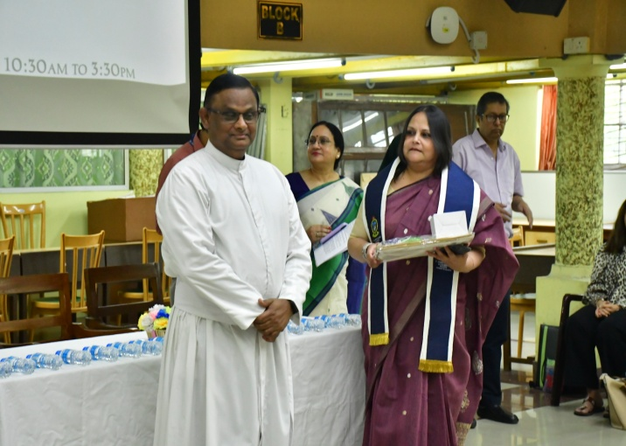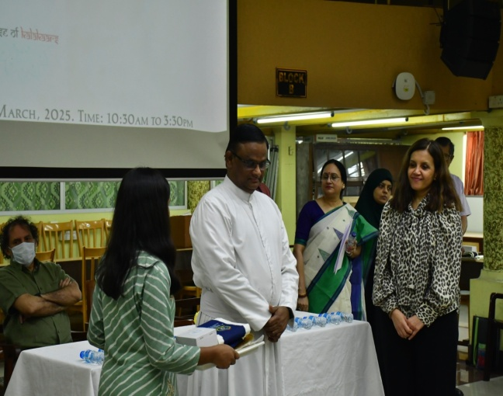

On March 11, 2024, a collaborative roundtable was convened by Asia in Global Affairs (AGA) and the Department of Political Science, St. Xavier’s College (Autonomous), Kolkata, titled “2024: A Pivotal Year of Elections – Elections in Asia: Political Continuities, Disruptions, and Democratic Contestations.” The event brought together a distinguished group of scholars from diverse academic and institutional contexts, designed as a critical forum to reflect on the theoretical and empirical implications of electoral processes in Asia amidst a landmark electoral year.

The roundtable was moderated by Professor Kingshuk Chatterjee, Department of History and Political Science, who opened the discussion by framing the theoretical stakes of electoral democracy in the Asian context. He emphasized how elections, while normatively linked to democratic consolidation, often operate as strategic instruments for authoritarian regimes, revealing the structural fault lines in many political systems. He further elaborated on the Indian experience to illustrate the interplay between democratic aspiration and institutional erosion, thereby linking regional patterns to broader conceptual debates.The session commenced with introductory remarks by Dr. Jhumpa Mukherjee, Head, Department of Political Science, St. Xavier’s College, who underlined the analytical urgency of interrogating electoral politics beyond procedural legitimacy, especially in a year where democratic institutions across South, Southeast, and West Asia face critical tests. The inaugural session was graced by Rev. Dr. Dominic Savio, SJ, Principal of St. Xavier’s College, who commended the Department for its initiative and emphasized the value of sustained academic-public interface through partnerships like that with Asia in Global Affairs
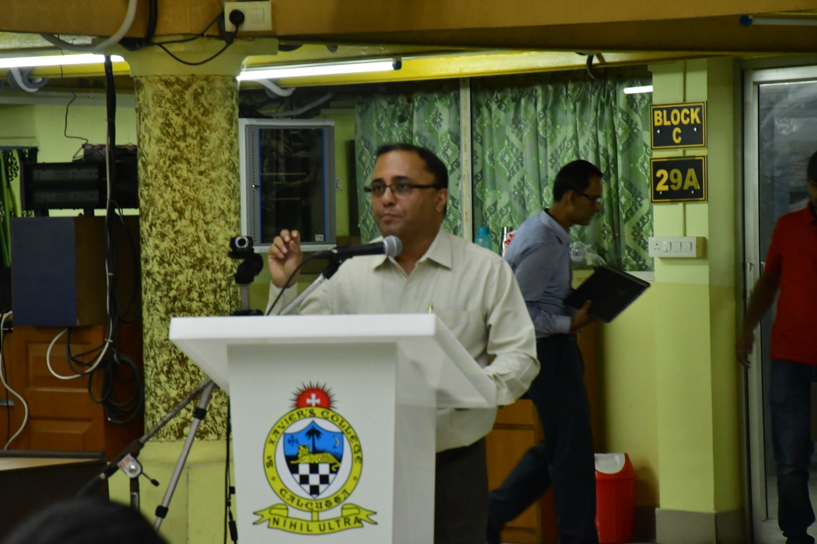

The roundtable aimed to critically examine the role of elections in structuring political power across Asia, engaging with the multifaceted realities of electoral practices across diverse political regimes and cultural contexts. While elections are conventionally viewed as mechanisms for political participation, representation, and accountability, the discussions challenged these normative assumptions by foregrounding the paradoxes inherent in the practice of electoral democracy. Across much of Asia, electoral exercises have been co-opted as instruments for consolidating political power rather than expanding democratic space. Participants emphasized that while the procedural aspects of elections—universal suffrage, regular polling cycles, and the presence of political parties, are largely in place, they often mask deeper systemic exclusions, including the marginalization of dissent, suppression of opposition, and curtailment of civil liberties.
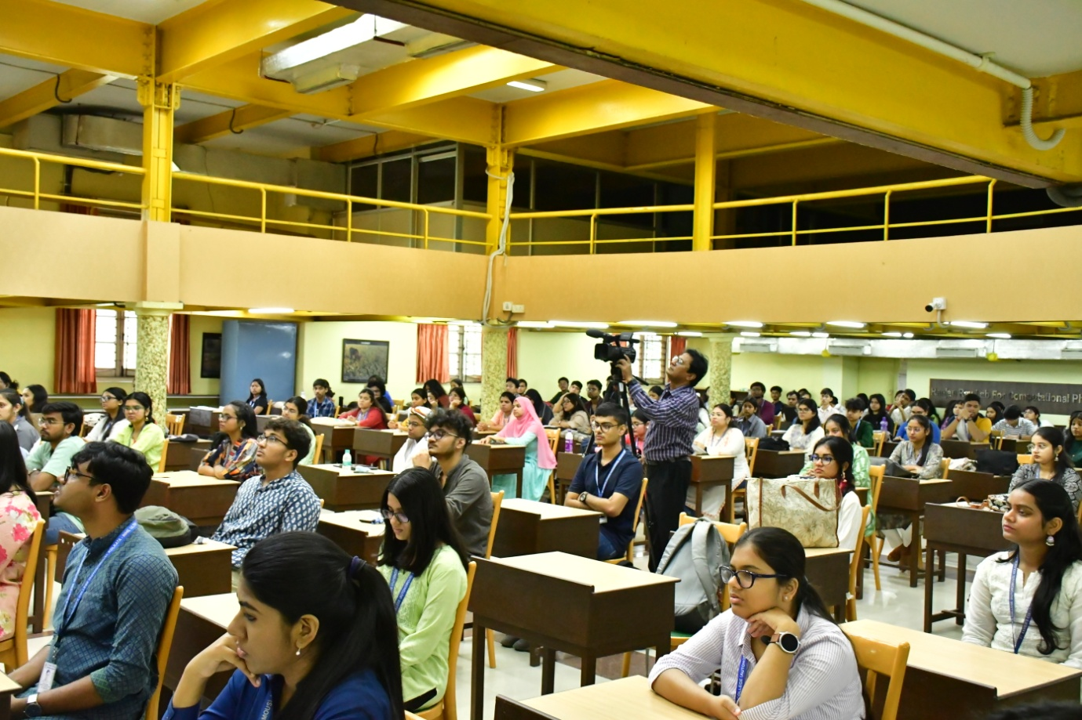
A recurring theme was the rise of electoral authoritarianism, wherein regimes maintain the façade of democratic legitimacy through elections that are manipulated, staged, or strategically designed to ensure the dominance of ruling parties and entrenched elites. The roundtable delved into how such regimes utilize electoral laws, gerrymandering, media control, and legal repression to undermine meaningful competition while appearing compliant with democratic norms. In many cases, electoral institutions, such as election commissions or constitutional courts, are either politically compromised or rendered ineffective, further weakening the integrity of democratic processes.
The conversation also underscored the limits of representational politics, with particular attention to the exclusion of historically marginalized communities, and religious minorities, women, indigenous populations, and economically disenfranchised groups. It was observed that electoral frameworks in Asia often operate within majoritarian logics that suppress pluralism and reinforce dominant ethno-religious and socio-economic hierarchies. Even when representation is formally achieved, it frequently amounts to symbolic inclusion rather than substantive political agency. This raises important questions about the nature of democratic legitimacy and whether elections alone suffice in constituting a democratic polity.
Importantly, the roundtable interrogated the intersection of global democratic discourses and local political realities. It was acknowledged that Western liberal models of democracy often serve as benchmarks for assessing electoral integrity, yet these frameworks may be ill-equipped to account for the specificities of postcolonial states, hybrid regimes, and authoritarian democracies in Asia. Participants urged the need to reframe analytical categories and methodologies in order to better understand how democracy is being imagined, negotiated, and contested in the region.
With 2024 marking a pivotal electoral year across South, Southeast, and West Asia, including national and municipal elections in countries such as India, Indonesia, Pakistan, Sri Lanka, Bangladesh, Bhutan, Israel, and Turkey, the roundtable recognized this moment as a critical juncture for assessing the durability and direction of democratic trajectories. It sought to analyse not only the outcomes of these elections but the structural and institutional conditions that shape them. In doing so, the discussion foregrounded the centrality of elections as both a mirror and mechanism of political transformation—capable of reflecting popular aspirations, yet equally vulnerable to elite capture and authoritarian resurgence.
By bringing together academic voices from across the region, the roundtable facilitated a rich and critical dialogue on the present and future of electoral democracy in Asia, emphasizing the need to move beyond surface-level metrics of democratic performance and toward a more grounded, context-sensitive understanding of power, representation, and legitimacy. It also created space for students and early-career scholars to engage with contemporary debates, furthering the pedagogical mission of the collaboration between St. Xavier’s College and Asia in Global Affairs.
Following the introductory remarks, the roundtable proceeded with a series of in-depth presentations by invited speakers, each of whom examined the electoral landscapes of different Asian states. Their insights collectively spanned a diverse regional arc, Bhutan, Israel, Turkey, Bangladesh, Indonesia, and Myanmar, highlighting the varying modalities through which electoral democracy is shaped, contested, and constrained across the continent. The event followed a hybrid format, enabling broader participation and scholarly exchange; notably, the presentations on Indonesia and Myanmar were delivered virtually, facilitating transnational academic dialogue despite geographical distance. The following summaries capture the key arguments and reflections from each of their interventions.
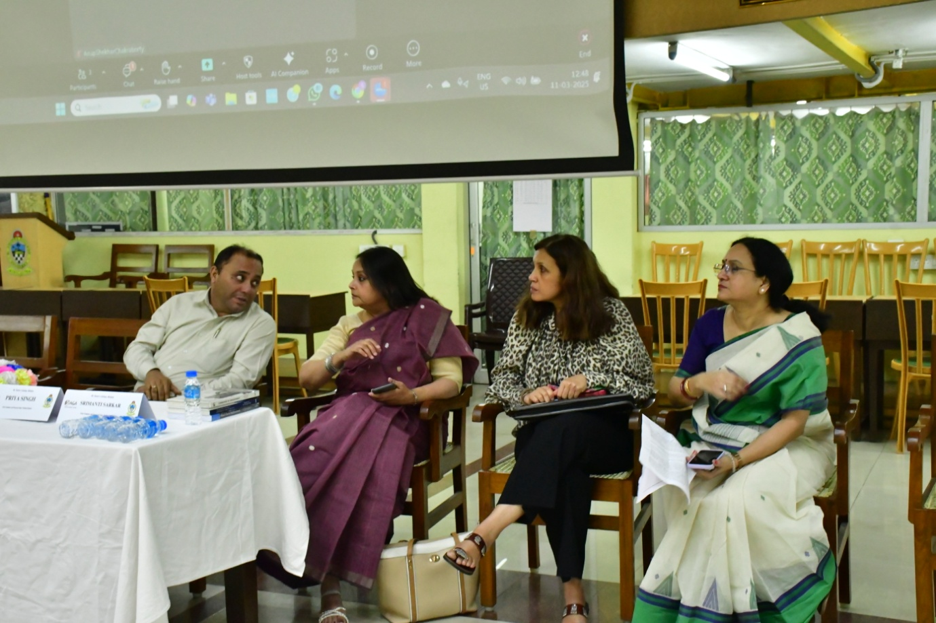
Dr. Anup Shekhar Chakraborty, Associate Professor, Department of Political Science, North-Eastern Hill University (NEHU), Shillong, offered a comprehensive reflection on Indonesia’s political evolution, tracing its journey from Sukarno’s Guided Democracy to the emergence of what he termed “vigilante democracy.” He argued that Indonesia’s democratic transition, though significant, remained deeply entangled in dynasticism, elite patronage, and religious identity politics. While Suharto’s New Order delivered economic growth, it entrenched corruption and political repression, laying the groundwork for post-authoritarian institutions still shaped by clientelism and social inequalities. Dr. Chakraborty underscored how informal civil society actors, often mobilized through digital platforms, had become key players in demanding accountability, though sometimes contributing to polarization and misinformation. He also examined the role of Islamic parties in shaping Indonesia’s democratic narrative, pointing to their increasing influence and the tensions between religious conservatism and democratic inclusivity. Particular attention was paid to gender dynamics, where progress remained constrained by cultural and religious norms, despite constitutional guarantees. Dr. Chakraborty concluded by emphasizing the contradictory nature of Indonesia’s political development
Mr Sanjay Pulipaka, Chairperson, Politeia Research Foundation, examined Myanmar’s electoral history within the broader context of military hegemony and democratic fragility. He traced the trajectory from the 1947 Constituent Assembly elections through the pivotal 1990 victory of the National League for Democracy (NLD), which was later nullified by the military. Pulipaka highlighted the structural entrenchment of military dominance through the 2008 Constitution, which guaranteed parliamentary seats and veto power to the armed forces. He emphasized the significance of the 2015 elections, which saw the NLD's rise with widespread support, and the 2020 elections, which consolidated their mandate amidst improved electoral procedures. However, he noted that over 1.5 million citizens, especially in ethnic minority regions, were excluded from voting due to security concerns. Pulipaka argued that while elections remained essential for representation, democratic consolidation required robust institutions—such as an independent judiciary, civilian bureaucracy, decentralization frameworks, and functional political parties. He cautioned that without these complementary structures, elections alone could not safeguard democracy. Reflecting on the 2021 military coup, Pulipaka concluded that Myanmar’s democratic crisis was rooted not only in electoral subversion but also in the persistent imbalance of civil-military relations, and underscored the urgent need to uphold electoral mandates and rebuild democratic institutions.
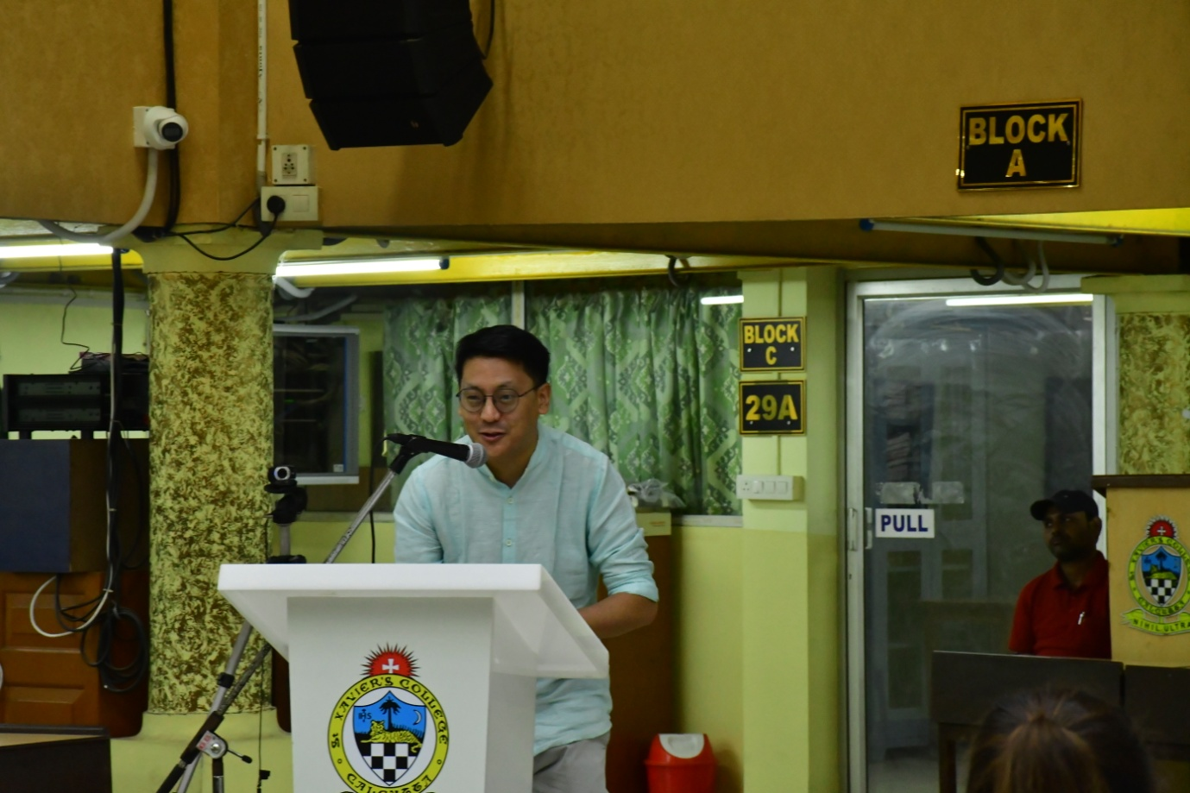
Dr. Jigme Yeshe Lama, Assistant Professor, Department of Political Science, University of Calcutta, characterized Bhutan's democracy as a "choreographed dance," directed by the monarchy, acknowledging its youth and unique trajectory. While some might view the monarchy's continued influence as a potential source of division, he argued that it had been instrumental in fostering democracy, notably through critical elections. He highlighted the distinctive features of Bhutan's electoral system, including stark variations in constituency sizes and the growing participation of political parties, citing the 2024 elections where the PDP emerged victorious and the DNT secured seats. However, he also raised concerns about emerging regionalism, as evidenced by the PDP's limited success in the east and the DNT's regional weaknesses, and the impact of historical grievances and ethnic tensions on voting patterns, particularly in the south. Emphasizing the monarchy's enduring influence, exemplified by the king's engagement with the people, Dr. Lama underscored that Bhutan's democratization, though adhering to principles of rights and equality, was a distinct and ongoing negotiation, shaped by its unique historical and cultural context, and differing from Western liberal models.
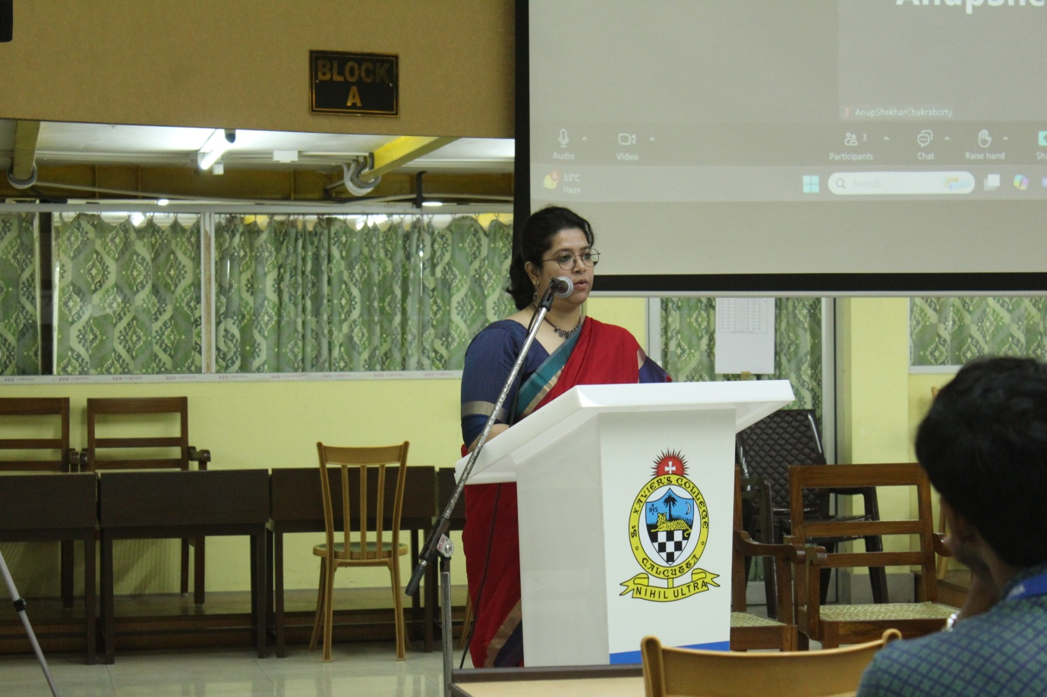
Ms. Srimanti Sarkar, Assistant Professor, Department of Political Science, West Bengal State University, analysed Bangladesh's electoral politics, highlighting the gap between formal elections and substantive democracy. She argued that elections in Bangladesh have increasingly become tools for government control rather than genuine opportunities for representation. Ms. Sarkar pointed to the 2014 and 2018 elections, marked by allegations of manipulation, suppression of opposition, and human rights abuses, as examples of elections that did not lead to democratic governance. She discussed the current political climate, characterized by disenchantment among the populace, a resurgence of opposition popularity, and uncertainty about future elections. Ms. Sarkar also addressed the relationship between electoral outcomes and social inequalities, noting that recent political changes have not addressed persistent issues like communal violence and economic instability. Finally, she emphasized the need to contextualize Bangladesh's democratic experience within broader global discussions, arguing that Asian realities require a nuanced understanding beyond conventional Western democratic models.
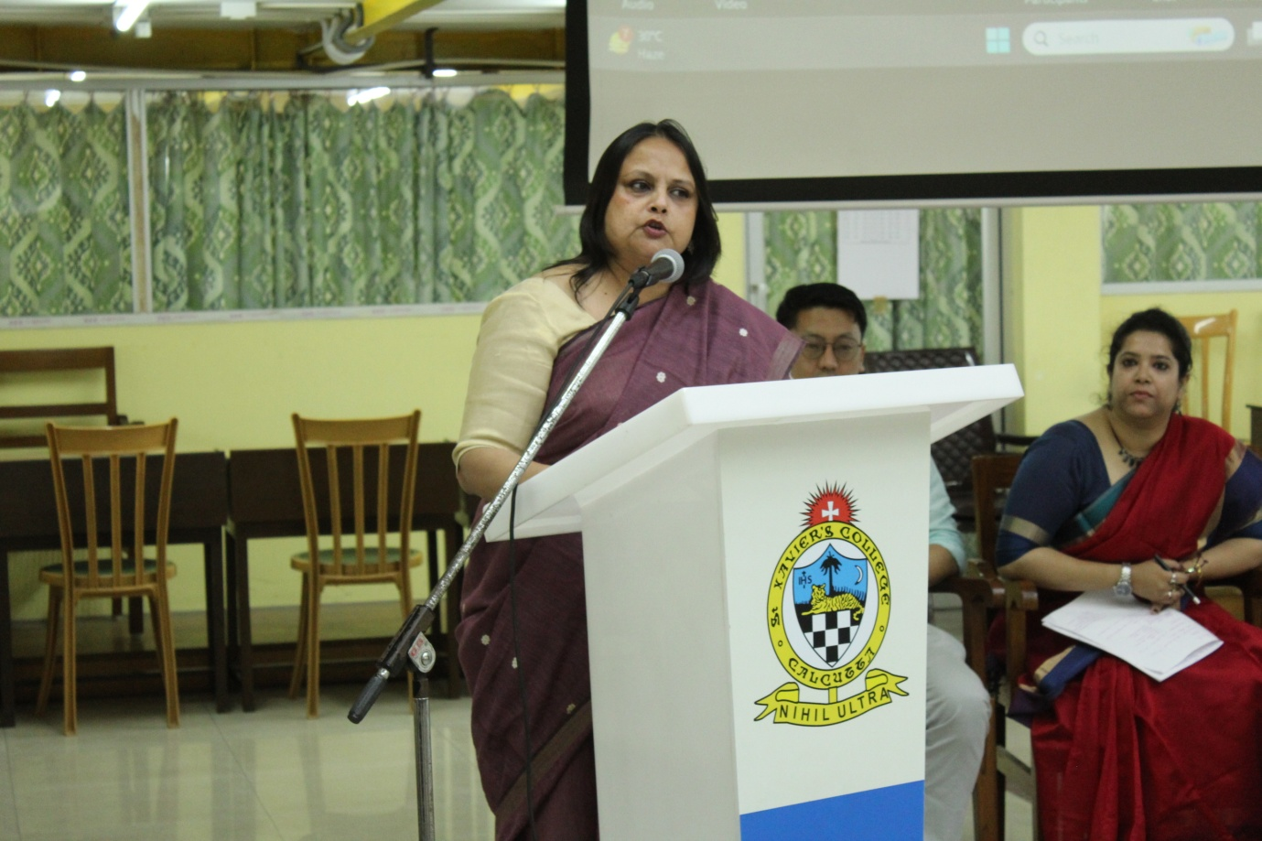
Dr. Anita Sengupta, Director, Asia in Global Affairs, described the evolution of Turkish electoral politics, highlighting the shift from a perceived model of democracy to a more authoritarian system. She emphasized the historical role of the military in Turkish politics, citing multiple coups that interrupted democratic processes. The emergence of the Justice and Development Party (AKP) in 2001 marked a significant change, initially presenting itself as a moderate conservative party. However, Dr. Sengupta detailed the AKP's increasing authoritarian tendencies, particularly after the 2013 Gezi Park protests, which exposed a deep societal divide. She noted the AKP's manipulation of the constitution, its crackdown on opposition voices, and its use of nationalist and religious rhetoric to consolidate power. Despite these authoritarian measures, the AKP maintained electoral success, which Dr. Sengupta attributed to its support base among emerging small businessmen and rural communities who felt marginalized by the traditional secular elite. She also mentioned the Kurdish-dominated HDP's impact on the 2015 elections, and the AKP's later losses in 2019 local elections, demonstrating a nuanced and shifting electoral landscape. Finally, she raised the point that people vote differently at a local and national level.
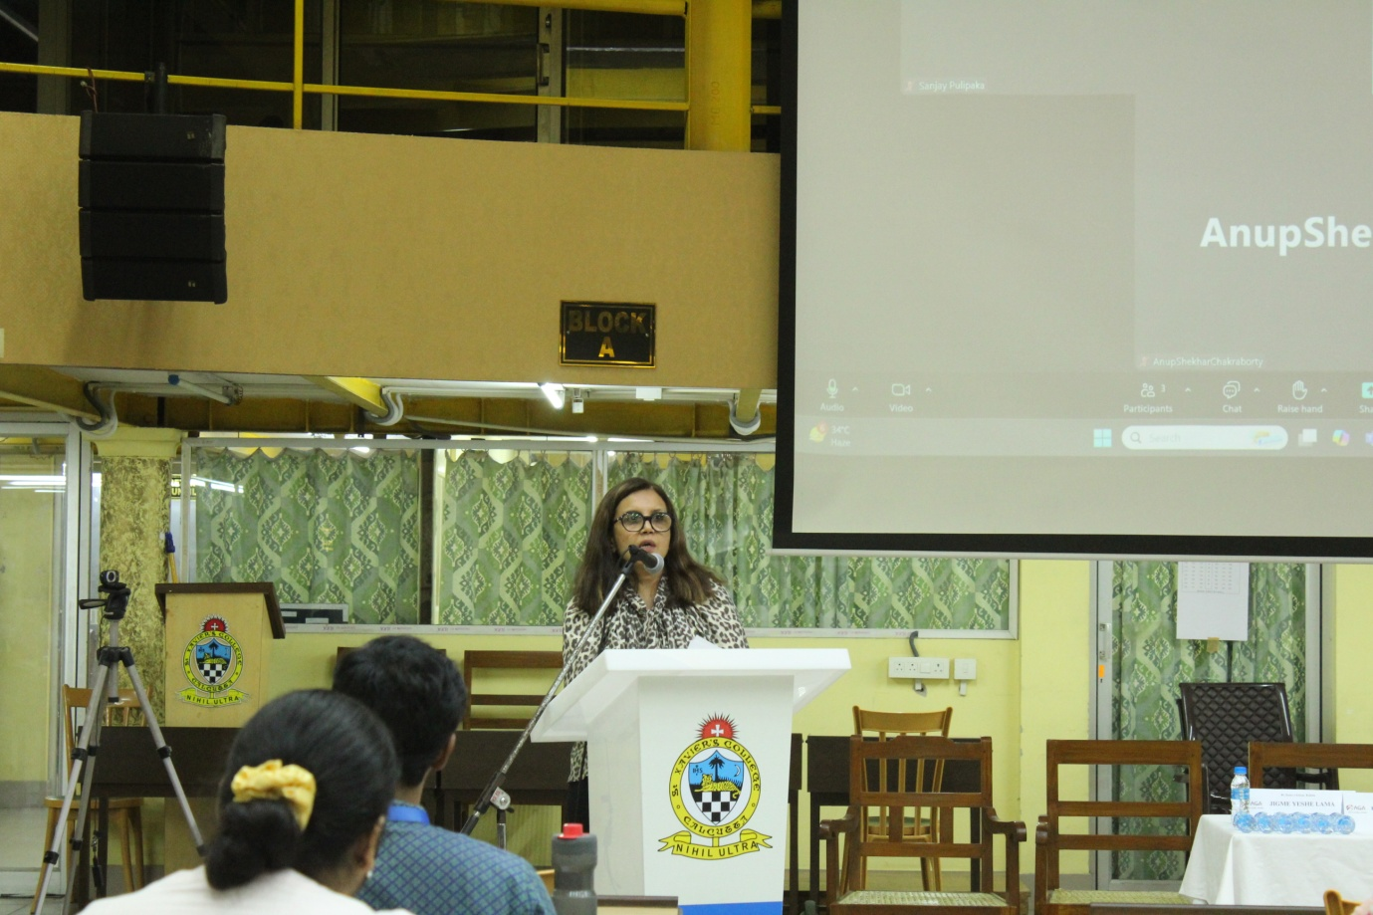
Dr. Priya Singh, Associate Director, Asia in Global Affairs, highlighted the complexities of Israeli electoral politics, emphasizing that while Israel possesses the formal structures of a parliamentary democracy with proportional representation, its system is marked by significant fragmentation and instability. She pointed to the absence of a formal constitution, relying instead on basic and electoral laws, and a low electoral threshold that contributes to numerous political parties in the Knesset. Dr. Singh stressed that despite the appearance of a functioning electoral system, the reality is far from a fully representative democracy. She cited the 2018 Nation-State Law, which prioritizes Jewish identity, and the 2023 judicial reforms, which weakened judicial oversight, as examples of policies that marginalize certain groups and undermine democratic principles. She also raised the critical question of whether Israel's democracy can be considered legitimate given its occupation of the West Bank and Gaza, questioning the extent to which elections truly reflect democratic values in the context of ongoing occupation and societal divisions.
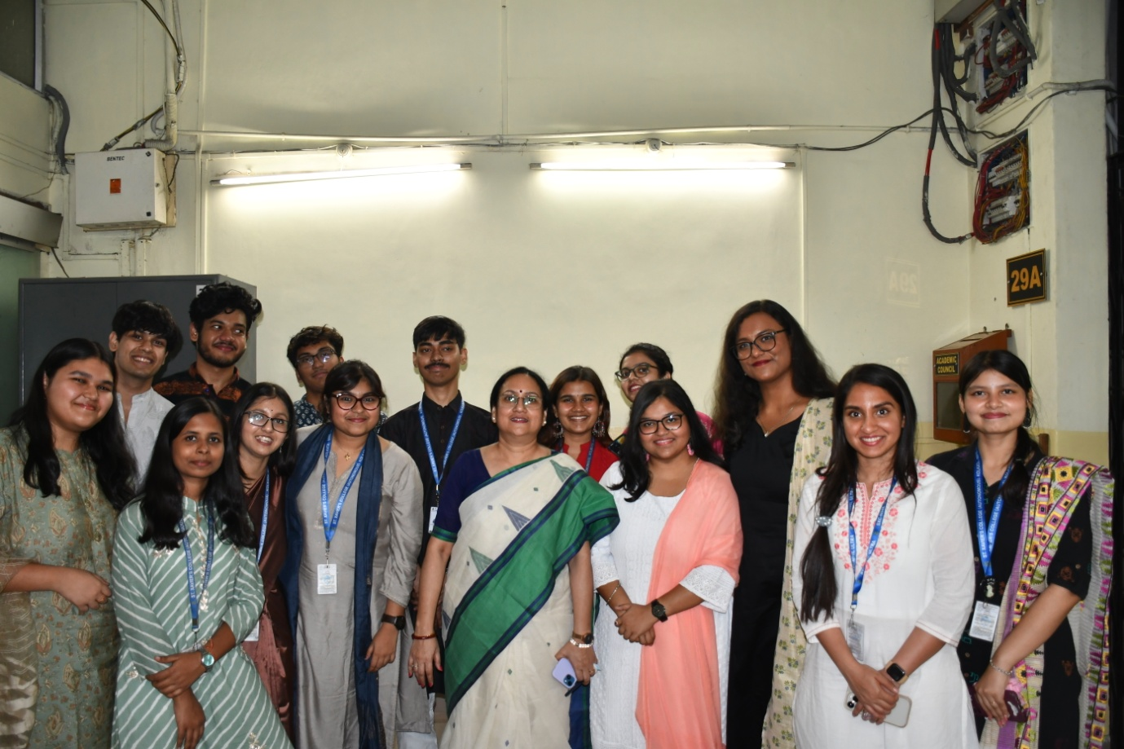
The roundtable concluded with a strong reaffirmation of the urgency to interrogate the shifting dynamics of electoral democracy across Asia, especially amidst deepening authoritarian impulses and structural exclusions. The conversations were rich, critical, and comparative, emphasizing the need to move beyond apparent electoral performances to the deeper questions of legitimacy, representation, and accountability. The post-lunch session brought renewed energy to the forum, as a series of thoughtful, vibrant, and intellectually animated student presentations injected fresh perspectives into the day’s deliberations, underlining the value of intergenerational dialogue in shaping the future of democratic discourse in the region.

