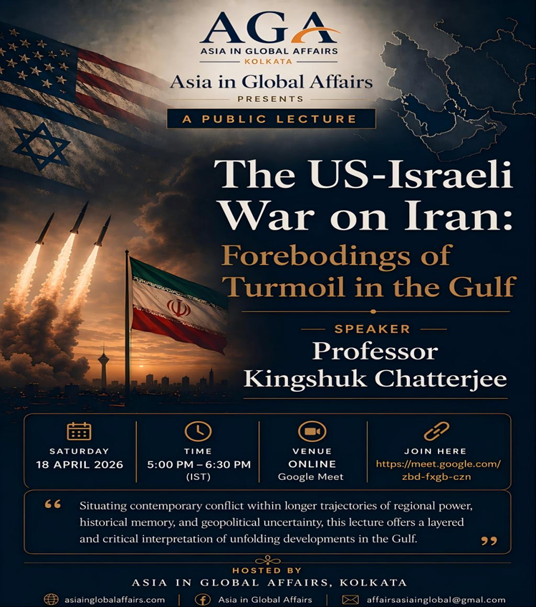

The US–Israeli War on Iran: Forebodings of Turmoil in the Gulf
A talk by Professor Kingshuk Chatterjee
Introductory Remarks
The session opened with remarks by Dr. Priya Singh, Associate Director, Asia in Global Affairs, who introduced Professor Kingshuk Chatterjee and then invited him to begin his lecture.
Professor Chatterjee is a distinguished historian of the modern Middle East, whose work focuses on political thought, intellectual history, and the evolving contours of regional and global order. His scholarship engages closely with questions of political Islam, state formation, and ideological transformation, particularly in relation to Iran and the broader West Asian region. Currently serving as Professor of History at the University of Calcutta, he has previously been associated with institutions such as Shiv Nadar University and has held international academic appointments, including a Fulbright Scholar-in-Residence position. His academic work is marked by a sustained effort to situate contemporary conflicts within longer historical trajectories, thereby offering nuanced and historically grounded interpretations of present-day developments.
He is the author of Ali Shariati and Political Islam in Iran (Palgrave Macmillan, 2011) and A Split in the Middle: The Making of the Political Center in Iran, 1987–2004 (Knowledge World Publishers, 2012), and has edited several volumes, including Political Fault Lines in the Middle East (Routledge, 2023). Across his writings, he traces the interplay between ideology, governance, and regional dynamics with conceptual clarity and archival depth. He is also affiliated as a Distinguished Fellow with the Centre for Middle East and Global Order, Berlin, and his work offers interpretations that remain attentive to regional particularities while situating them within broader global processes.
Professor Chatterjee began his address by expressing his gratitude to the organizers, particularly Dr. Anita Sengupta, Director, and Dr. Priya Singh, Associate Director of Asia in Global Affairs, for the opportunity to inaugurate what was described as the first lecture in a planned series.
Lecture
Professor Kingshuk Chatterjee outlined the focus of his lecture, stating that he would address the ongoing conflict in the Middle East, which he described as a matter of global concern with particularly acute regional consequences. He noted that while international attention, especially in the Indian media, often remains limited to issues such as disruptions in oil and gas supply, the actual impact of the conflict on the region is far more profound and far-reaching. He framed his discussion around what he termed, a “foreboding of turmoil” in the Gulf, emphasizing that the consequences of the war are unlikely to dissipate with the cessation of hostilities. Rather, like most conflicts, it is expected to produce long-term repercussions that will resonate globally.
Professor Chatterjee characterized the ongoing US–Israeli war on Iran as historically distinctive, even within the conflict-prone context of the Middle East. He pointed out that the dominant narrative presented by global media that the war aims to prevent Iran from acquiring nuclear weapons has not been entirely convincing to many observers. He argued that this justification, frequently articulated by American and Israeli officials, has failed to generate widespread acceptance, even among sections of the American public and strategic community. Instead, he suggested that the conflict may be better understood as a response to Israel’s security concerns and its opposition to the normalization of Iran’s position within the international system.
He further observed that the outbreak of hostilities occurred at a time when negotiations between the United States and Iran on the nuclear issue were still ongoing, with credible indications that Iran may have been nearing a possible compromise. Several commentators have expressed skepticism regarding the abrupt termination of these negotiations, which preceded the outbreak of hostilities on 28 February, suggesting that the decision was driven less by American dissatisfaction with the progress of the talks than by Israeli assessments of its own security vulnerabilities. For many Iranians, Israelis, and even sections of the American public, the conflict thus appears to be motivated more by an attempt to destabilize the Islamic Republic than by a genuine effort to resolve the nuclear question.
There is also a growing global recognition that the failure to achieve regime change in Iran, despite military escalation, reflects a significant strategic miscalculation on the part of the United States and Israel. This misjudgment carries the potential to push the region into a prolonged phase of uncertainty, comparable to the instability witnessed during the oil shocks of 1967–73, and arguably exceeding even the upheaval following the Iranian Revolution of 1979. The character of the ongoing conflict is itself notable for its distinctiveness.
In analyzing the nature of the conflict, he highlighted the pronounced asymmetry in military capabilities between the two sides. While the United States possesses unmatched military power, it has deployed only a limited portion of its resources, relying primarily on naval and aerial capabilities. Its involvement has been restricted to a relatively small naval and aerial presence, including a few aircraft carriers, submarines, and supporting vessels, along with the associated strike capabilities they carry. This measured deployment suggests that the United States is not engaging Iran with its full military strength. At the same time, the United States appears to be operating in support of Israel, the dominant military power in the Middle East. Israel possesses highly advanced air capabilities, benefits from consistent American logistical and material support, and maintains one of the most sophisticated missile defense systems currently in operation. This alignment underscores the strategic imbalance in the conflict while also highlighting the layered nature of military cooperation shaping its course.
In contrast, Iran possesses one of the largest standing military and paramilitary forces in the region, though it remains comparatively limited in terms of air and naval power, with a significantly weakened aerial defense system. To compensate for these structural vulnerabilities, Iran has, over the past two decades, invested heavily in the development of an extensive ballistic missile program as well as advanced drone capabilities. These capacities, which gained wider recognition during the Ukraine conflict, have become central to Iran’s strategic posture, with Iranian drones now actively deployed not only over Israeli territory but across the Gulf region, heightening regional alertness.
In addition to its domestic military capabilities, Iran has cultivated a network of allied nonstate actors, including groups such as Hamas, Hezbollah, Hashd al-Shaabi, and the Houthis. Through these affiliations, Iran’s strategic reach extends beyond its territorial boundaries, enabling it to project influence across the wider region. Despite this, the imbalance in conventional military capabilities between Iran and its adversaries remains substantial. In the event of a full-scale, direct confrontation particularly involving the full deployment of American military power Iran would face overwhelming disadvantage, with Israel’s participation potentially becoming secondary in such a scenario.
Expectations that the Islamic Republic would collapse rapidly—either through targeted decapitation of its leadership, including the possible elimination of Supreme Leader Ali Khamenei, or through the emergence of widespread domestic unrest—have not materialized. Assumptions that internal dissent would escalate into a broader uprising, building on earlier episodes of unrest, have proven unfounded. Neither leadership decapitation strategies nor anticipated popular upheavals have succeeded in destabilizing the regime, underscoring the limits of these initial strategic calculations. Despite the imbalance in capabilities, Professor Chatterjee noted that Iran has demonstrated an unexpected capacity to withstand sustained military pressure. Initial expectations that the conflict would lead either to the rapid collapse of the Iranian regime through targeted decapitation strategies or to widespread domestic unrest have not materialized. Instead, Iran has maintained internal stability while adapting its military strategy, including targeting US interests in the Gulf and employing asymmetric tactics such as the strategic disruption of the Strait of Hormuz.
He described the conflict as fundamentally shaped by miscalculations on multiple sides. The decision to initiate hostilities during ongoing diplomatic negotiations, he argued, reflects a breakdown in strategic judgment. He also pointed to the role of political leadership, particularly in the United States and Israel, suggesting that domestic political considerations and misjudgments about Iran’s internal resilience contributed to the escalation. Professor Chatterjee further argued that a particularly troubling dimension of the conflict lies in the methods adopted by Tehran to ensure regime security. While these tactics have demonstrated a degree of strategic effectiveness, they also risk intensifying instability across the wider region. In particular, Iran’s targeting of American bases and US-linked assets in the Gulf represents an escalation that may have extended the conflict beyond its initially anticipated limits. As a result, the developments observed throughout March and into mid-April can be understood as constituting a “war of miscalculations,” marked by actions that have produced unintended and potentially far-reaching consequences.
He reiterated that the conflict began while the United States and Iran were still actively engaged in negotiations over the nuclear issue, with diplomatic options not yet exhausted. It is widely suspected that policymakers in Tel Aviv viewed the prospect of normalization as incompatible with their security calculus, prompting a pre-emptive strike aimed at preventing any diplomatic breakthrough. Broader analyses similarly suggest that military escalation was chosen despite the continued viability of a negotiated outcome.
Professor Chatterjee further noted that Israeli Prime Minister Benjamin Netanyahu played a significant role in persuading former US President Donald Trump that the targeted assassination of Ali Khamenei would trigger the collapse of the Iranian regime. However, many American strategic experts had expressed skepticism regarding the effectiveness of such a decapitation strategy, arguing that it was unlikely to produce regime collapse. Subsequent developments appear to have validated these concerns, as the removal of key leadership figures did not result in the anticipated internal breakdown, instead, it contributed to greater consolidation within Iran and an escalation of hostilities.
Professor Chatterjee also reflected on the role of political decision-making in Washington, suggesting that expert advice was sidelined in favor of more immediate political considerations. He argued that President Trump’s approach to the conflict appeared shaped by a desire to secure a decisive geopolitical outcome, particularly within the context of domestic electoral politics. This tendency was consistent with a broader pattern of assertive and often unconventional interventions in global affairs, which created an impression of unpredictability but also encouraged risk-taking at the highest levels of decision-making.
Once engaged in the conflict, however, the United States found itself constrained by the necessity of projecting success. Professor Chatterjee observed that official rhetoric increasingly framed the conflict in terms of victory, irrespective of the actual outcomes on the ground. This imperative to claim success limited the scope for de-escalation and contributed to the prolongation of hostilities. At the same time, Israel appeared to encourage the continuation of the campaign, seeking to maximize strategic gains while Iran remained under sustained pressure.
He further noted that this logic of escalation extended beyond Iran itself, as evidenced by Israel’s decision to broaden the theatre of conflict, including military operations in Lebanon. Such actions indicate that the conflict is embedded within a larger regional strategy rather than being confined to a single bilateral confrontation. Since late 2023, Israel’s strategic posture has undergone significant transformation, and the current war reflects this shift in both its scale and its objectives.
Professor Chatterjee argued that, contrary to prevailing representations, the ongoing conflict reflects a return to a mode of warfare that closely resembles what has historically been described as “total war,” wherein the distinction between civilian and military targets becomes increasingly blurred. In this context, he identified Israel as the primary belligerent, noting that its military operations have extended beyond clearly defined military objectives to include civilian targets that are subsequently framed as legitimate through claims of militant presence. Drawing parallels with patterns observed during the Gaza conflict, he explained that attacks on sites traditionally regarded as off-limits, such as hospitals or residential complexes, are often justified on the grounds that they allegedly house operatives affiliated with groups such as Hamas or Hezbollah. This rationale effectively reclassifies civilian spaces as military targets, thereby expanding the scope of permissible strikes.
He noted that even minimal associations, such as the presence of a single member of the Islamic Revolutionary Guard Corps within a residential complex, are deemed sufficient to render such locations legitimate targets. While civilian casualties have historically been described as collateral damage in warfare, Professor Chatterjee emphasized that the scale and explicit justification of such actions in the present conflict mark a significant departure. Although he acknowledged that such practices are not unique to Israel, he argued that their execution in this instance has been marked by an unusual degree of explicitness. Furthermore, Israel’s systematic targeting of regime and government functionaries represents a notable shift from its earlier, more cautious approach.
By way of comparison, he referred to the assassination of Qasem Soleimani, the former head of the Quds Force, noting that while intelligence inputs were reportedly provided by Israel, the operation itself was carried out by the United States. This earlier episode reflected a more restrained Israeli posture within the framework of a “shadow war” aimed at countering Iranian influence in the region. In contrast, the current conflict indicates that such inhibitions have largely been abandoned.
Turning to the role of the United States, Professor Chatterjee observed that American operations have, for the most part, remained focused on military targets, albeit with notable exceptions. Incidents such as the reported strike on a school in Manab, which resulted in significant civilian casualties, were described as miscalculations rather than deliberate targeting. However, he cautioned that the United States has also demonstrated a willingness to consider strikes on civilian infrastructure, including bridges, oil and power installations, and water desalination facilities, which are traditionally regarded as off-limits due to their non-military character.
Iranian responses, while generally directed at military installations, have not been entirely confined to such targets. Attacks on areas surrounding military bases and on locations in Gulf states such as Dubai, Abu Dhabi, and Qatar illustrate the extent to which civilian zones have also been implicated, particularly where tenuous connections to US presence exist. These patterns indicate that the erosion of the civilian–military distinction is not limited to one side but is a broader feature of the conflict.
Despite its relative limitations in conventional warfare, Iran has demonstrated notable tactical adaptability, particularly through its efforts to restrict access to the Strait of Hormuz as a form of area denial. This strategic move underscores the importance of the waterway as a critical global chokepoint and signals Iran’s willingness to leverage geographic advantages in response to military pressure. He argued that this development marks a significant shift, as Gulf states can no longer assume insulation from direct conflict.
Professor Chatterjee observed that Iran’s aerial defense capabilities have been severely degraded, particularly since the Israeli airstrikes of October 2024, leaving the country highly vulnerable to sustained airborne attacks. This erosion of defensive capacity has enabled repeated strikes on Iranian territory with relatively limited resistance. Despite this disadvantage, however, Iran’s missile program has demonstrated increasing effectiveness, particularly in penetrating Israel’s multilayered missile defense architecture, which includes systems such as Iron Dome, Arrow, and David’s Sling. These systems are designed to intercept threats across varying ranges, yet Iranian strikes have shown a rising rate of successful penetration over time.
He noted that Iran has adapted its strategy by reducing the frequency of missile launches while increasing their precision and targeting higher-value objectives. This shift has coincided with the rapid depletion of Israeli interceptor stockpiles, compelling Israel to be more selective in its defensive responses. Consequently, Iranian strikes, though fewer in number, have achieved greater impact. In response, Israel has intensified efforts to target and eliminate Iranian missile-launch infrastructure, particularly in the period leading up to the ceasefire, in an attempt to offset its diminishing defensive reserves. Iranian targeting has also extended to sensitive strategic locations, including areas near the Dimona Nuclear Facility.
At the same time, both sides have expanded the scope of the conflict to include economic infrastructure, aiming to weaken each other’s war-making capacities. While Iran’s efforts in this regard have been comparatively limited, its strikes on facilities such as the Haifa refineries targets lacking clear military justification illustrate this escalation. Iran has also directed attacks toward US military assets in the Persian Gulf, likely seeking to create tensions between the United States and its regional allies, a strategy that appears to have achieved partial success.
Professor Chatterjee emphasized that, despite its overwhelming military superiority, the United States has remained reluctant to deploy ground forces. This hesitation, he argued, stems from concerns over potential casualties and their impact on domestic public opinion. He linked this caution to the legacy of the Iraq War, after which successive US administrations regardless of political affiliation have shown a consistent reluctance to engage in large-scale ground operations. This pattern, observable across the presidencies of Barack Obama, Joe Biden, and Donald Trump, reflects a broader strategic recalibration in American military doctrine.
He further noted that Israel’s growing concern over Iran’s missile capabilities has been reinforced by recent developments in the conflict. Should diplomatic negotiations resume, particularly in forums such as the Islamabad talks, Israel and the Gulf states are likely to insist on stringent limitations on Iran’s missile program—an issue that had already contributed to tensions surrounding the Joint Comprehensive Plan of Action. Given the demonstrated effectiveness of these capabilities, Iran is unlikely to concede on this point, rendering it a critical obstacle to any future agreement.
Professor Chatterjee suggested that the prospects for a negotiated settlement remain uncertain. If US policy aligns closely with Israeli demands, a deal may prove unattainable without the complete removal of sanctions—a politically difficult proposition within the United States. Conversely, if Washington seeks an expedient exit from the conflict, Iran may adopt a more assertive negotiating position, further complicating diplomatic efforts. In either scenario, he argued, both Iran and Israel are likely to prepare for renewed confrontation in the near future.
He also highlighted a significant shift in the nature of hostilities between the two states. Prior to 2024, despite longstanding tensions since the Iranian Revolution, there had been no sustained direct conflict between Iran and Israel. However, recent developments, including the so-called “12-day war” and the current confrontation, have demonstrated the capability and willingness of each side to strike directly at the other’s territory. This, he suggested, marks not the culmination but the beginning of a new phase of open conflict.
In this evolving context, the Strait of Hormuz is likely to assume increasing strategic importance. Iran’s demonstrated willingness to disrupt this critical maritime chokepoint signals a potential escalation pathway that could draw in Gulf states more directly. As a result, regional actors can no longer assume insulation from the conflict, and the Gulf’s perceived immunity has been significantly eroded. While some analysts caution against repeated attempts to weaponize the strait, the very fact that such a strategy has now been tested introduces new uncertainties into future conflict scenarios.
He concluded by reiterating that the current conflict should not be viewed as an isolated episode but rather as the beginning of a broader and more protracted phase of geopolitical turbulence. The interplay of military confrontation, economic disruption, and strategic miscalculation, he argued, has set in motion dynamics that are unlikely to be easily reversed. Iran’s economy, already weakened by decades of sanctions since 1979, has faced additional strain from recent military actions targeting its industrial infrastructure. Unlike earlier confrontations, the current conflict has involved deliberate efforts to degrade Iran’s economic capacity, suggesting a shift toward more comprehensive forms of strategic pressure. This combination of prolonged economic hardship and intensified military targeting, he argued, underpins the “foreboding of turmoil” that is likely to shape the region in the years ahead. As such, the region, and indeed the wider global order, must prepare for a period of sustained uncertainty, in which the repercussions of the conflict will continue to unfold over time.
The lecture was followed by an engaging question-and-answer session, and the formal vote of thanks was delivered by Dr Somdatta Chakrabarty, Senior Adjunct Researcher, Asia in Global Affairs.

Compiled by Sombrita Datta

